FOR IMMEDIATE RELEASE
April 10, 2026

ALSC and LSBA Launch Legal Incubator to Expand Rural Access to Justice.
The Louisiana State Bar Association (LSBA) and Acadiana Legal Service Corporation (ALSC) have partnered to address the shortage of affordable civil legal services in rural Louisiana. The LSBA’s Access to Justice Department administers the Legal Innovators for Tomorrow (LIFT) Program, a legal incubator designed to help new attorneys build viable, public interest–focused law practices while expanding access to justice for low- and moderate-income residents. Through the 12-month initiative, the LSBA and ALSC will support solo practitioners committed to offering affordable and pro bono legal services in underserved areas statewide.

ALSC, the federally funded civil legal aid provider for 42 parishes in north, central, and southwest Louisiana, is working with the LIFT program to launch the second phase of the Rural Justice Legal Incubator Project. This expansion targets some of the state’s most rural and underserved parishes, including Avoyelles, Cameron, Catahoula, Claiborne, Concordia, De Soto, East Carroll, West Carroll, Franklin, Grant, LaSalle, Madison, Morehouse, Sabine, Tensas, Union, and Vernon. The program addresses high-demand civil legal matters in these communities, including successions, family law, expungements, advance directives, bankruptcy, Social Security and disability claims, Child-in-Need-of-Care proceedings, housing disputes, and consumer protection issues. Demand for these services is rising, especially in northeastern Louisiana, where attorney shortages are most severe. This additional attorney support is expected to strengthen ALSC’s Monroe office and increase service capacity in rural parishes where legal representation is limited, and attorney recruitment has been the most difficult.

STRENGTHENING PRIVATE ATTORNEY INVOLVEMENT
The LIFT initiative also helps ALSC meet federal requirements set by the Legal Services Corporation (LSC). As an LSC grantee, ALSC must maintain a Private Attorney Involvement (PAI) program that allocates at least 12.5 percent of its basic field grant to engage attorneys to serve eligible clients. Through PAI, ALSC partners with private lawyers to provide pro bono services, greatly reduced-fee services, case referrals, clinics, and mentoring. All services must meet the same professional standards as in-house representation, and ALSC must track, document, and report PAI activities and expenditures. PAI is intended to expand access to legal services and to strengthen the delivery of high-quality civil legal aid across the service area. The collaboration with LIFT attorneys supports these goals by increasing capacity and developing a sustainable pipeline of public-interest practitioners in rural Louisiana.

MEET THE LIFT ATTORNEYS
Four attorneys have been selected for the one-year incubator program, each bringing unique experiences and a strong commitment to public service. Desiree Cotton-Turner, who graduated from Southern University Law Center and previously served as a public defender in Baton Rouge, launched her firm to expand access to affordable legal services across the state, focusing on family law, expungements, and estate planning. Miguel Robles-Coles, a graduate of LSU’s Paul M. Hebert Law Center, has primarily practiced immigration law, including detained and non-detained removal cases. Through the incubator, he aims to reach rural communities with affordable legal services in immigration, family law, expungements, and estate planning, helping residents navigate complex legal processes to improve their opportunities.

Sharita Spears, a Southern University Law Center graduate, has worked with the Louisiana Department of Public Safety and Corrections to ensure compliance with the Americans with Disabilities Act in the state’s prison system. By establishing her solo practice in 2021, she now offers affordable legal services in family law, successions, personal injury, and expungements, directly addressing legal gaps in northern Louisiana. Alexis Tukes-Jones recently graduated from Southern University Law Center. She previously clerked for Judge Ethel Julien at the Orleans Parish Civil District Court, which prepared her to launch her own practice. In offering affordable services in family law, estate planning, contracts, and property law, she is helping clients in rural parishes gain access to counsel.

BUILDING CAPACITY IN LOUISIANA’S LEGAL DESERTS
The LIFT partnership is more than individual practice development; it is a strategic investment in Louisiana’s legal infrastructure. ALSC and the LSBA work cooperatively to provide mentorship, training, continuing legal education, business development services, networking opportunities, and case referrals to participating attorneys. By supporting solo legal practitioners focused on public interest work, the program seeks to mitigate persistent attorney recruitment challenges in rural Louisiana “legal deserts”. This collaboration strengthens community outreach, increases service delivery, and expands access to civil justice for low-income families, seniors, and vulnerable residents. As ALSC works toward full staffing in its Monroe office and other northern parishes, partnering with the LSBA’s LIFT program offers a scalable, long-term solution to the ongoing high demand for affordable civil legal assistance in the state’s most underserved regions. For more information about the LIFT Rural Justice Legal Incubator Project, go to https://www.lsba.org/LIFT/RuralJusticeIncubatorProject.aspx.

Media Contacts:
April Guillote Amy Duncan Kelly Ponder
Communications Manager Access to Justice Director Communications Director
ALSC LSBA LSBA
(866) 275-2572 x1119 (504) 619-0148 (504) 619-0118
The Louisiana State Bar Association assists its more than 23,000 members in the practice of law. The statewide association, as part of its multi-faceted mission, promotes and maintains access to justice initiatives for the state’s residents, assists the Louisiana Supreme Court in its regulation of the practice of law, upholds the honor of the courts and the profession, and support programs that increase public understanding of and respect for the law.
Acadiana Legal Service Corporation (ALSC) is a private, non-profit law firm that provides free legal assistance in civil cases and community education to low-income communities throughout 42 parishes in south, central, and north Louisiana.
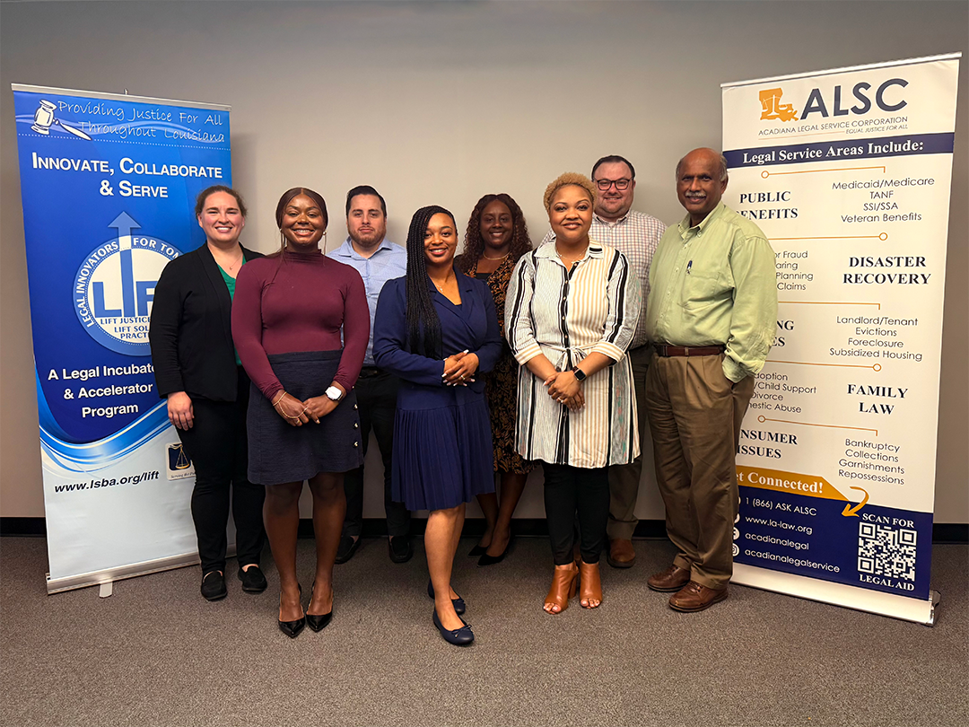
The LIFT Program (left to right): Emily Belanger, LSBA Access to Justice Projects Counsel; Amber Mason, Former LIFT fellow; Miguel Robles-Coles, Current LIFT Fellow; Alexis Tukes-Jones, Current LIFT Fellow; Sharita Spears, Current LIFT Fellow; Desiree Cotton-Turner, Current LIFT Fellow; Gregory Hopkins, ALSC Pro Bono Unit Managing Attorney; Sachida R. Raman, ALSC Executive Director.

